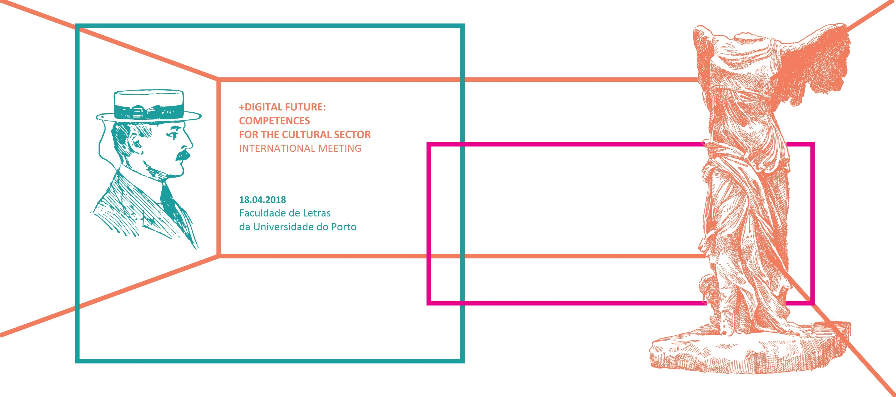
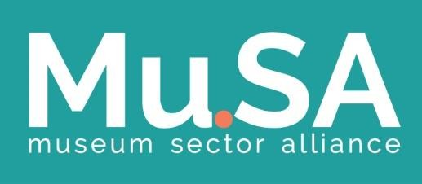

Registration Form
Participation
The attendance at the Meeting is free but this registration is mandatory. Please, send it to the Secretariat: uecre@letras.up.pt

Name: Clique aqui para introduzir texto.
Institution: Clique aqui para introduzir texto.
Telephone | Mobile: Clique aqui para introduzir texto.
E-mail: Clique aqui para introduzir texto.

Framework of the Meeting
This International Meeting is organized within the framework of the Erasmus+ KA2 Project Mu.SA_Museum Sector Alliance (http://www.project-musa.eu/; https://www.facebook.com/MuseumSectorAlliance/).

are you interested in receiving more information about the Mu.SA Activities and its Education and Training Programmes (MOOC and Specialization)?
YES ☐ | No ☐
If your answer is YES, do you give authorization to add your e-mail address to the stakeholders’ database?
YES ☐ | No ☐
Please note that if your answer is No, we won’t have ways to keep you informed.

For any doubt and/or more information
Please contact the Secretariat. Tel.: (+351) 220677105 | E-mail: uecre@letras.up.pt
